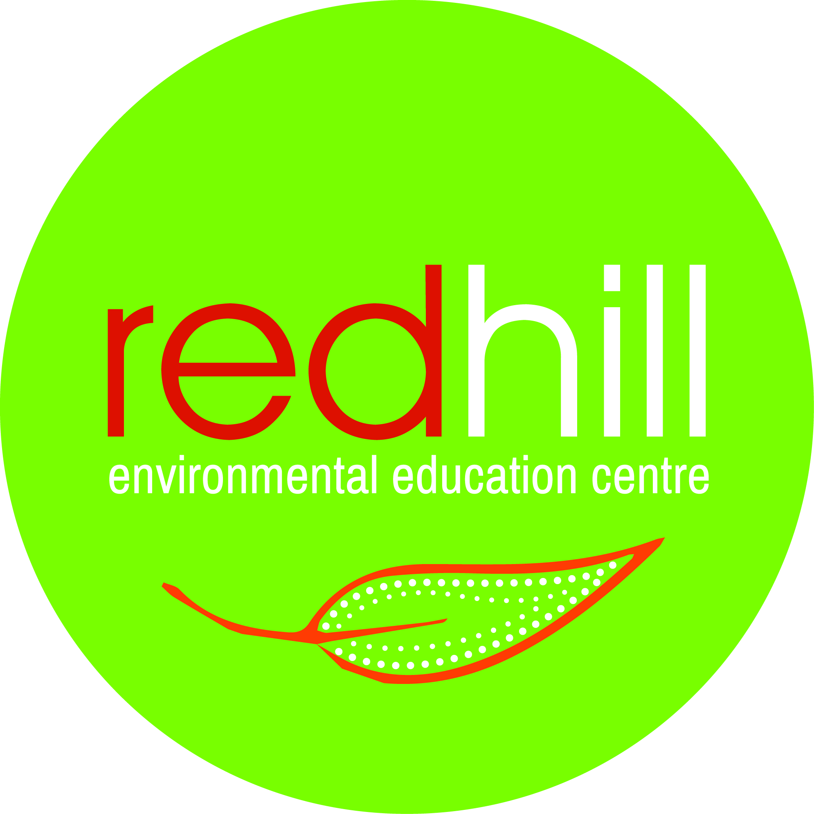
Overview: Environment Case Study. Students engage in fieldwork activities to investigate the ecological and cultural impacts of coal mining in the local area. They investigate the remediation and rehabilitation undertaken. Soil and water testing is undertaken.
Curriculum Focus and rationale: SCIENCE |  |  | Duration: 1 day
Syllabus Outcomes  A student undertakes first-hand investigations to collect valid and reliable data and information individually and collaboratively (SC5-6WS)  A student explains how scientific knowledge about global patterns on geological activity and interactions involving global systems can be used to inform decisions related to contemporary issues (SC5-13ES) | Syllabus Content  Students conduct investigations by:  Individually and collaboratively using appropriate investigation methods, including fieldwork and laboratory experimentation, to collect reliable data  Selecting and using appropriate equipment, including digital technologies, to systematically and accurately collect and record data  Using appropriate units for measuring physical quantities  Reporting data and information, evidence and findings, with accuracy and honesty  ES 2 The theory of plate tectonics explains global patterns of geological activity and continental movement  ES 3 People use scientific knowledge to evaluate claims, explanations or predictions in relation to interactions involving the atmosphere, biosphere, hydrosphere and lithosphere. Students discuss the reasons different groups in society may use or weight criteria differently to evaluate claims, explanations or predictions in making decisions about contemporary issues involving interactions of the Earth’s spheres. |  | Learning across the curriculum:  All Red Hill EEC activities utilise and reflect the principles of 8 Ways pedagogies for Aboriginal learning.  Sustainability  Aboriginal and Torres Strait Islander history and cultures  Critical and creative thinking  Ethical understanding  Personal and social capability  Numeracy
Learning Activity One: Site visit to Ulan Coal Mine
Students are given a presentation and tour at Ulan Coal Mine. This consists of:  Induction and introduction, including legislative context  Cultural Heritage DVD (viewed prior to day)  Goulburn River Diversion remediation area to see the rehabilitation work and do some testing  Visit Clean Water System and rehabilitation from the Ulan West viewing platform |  | Resources:  Cultural Heritage Induction DVD supplied by Ulan Coal  Workbook provided by RHEEC
Learning Activity Two: The Drip, Goulburn River
Travel to Drip picnic area for lunch.  Guided walking tour. Soil, water and macroinvertebrate testing undertaken at sites designated by Red Hill staff.  Completion of workbook using suitable measurements and accurate records. |  | Resources:  Workbook provided by RHEEC  Water testing equipment  Soil testing equipment  Macroinvertebrate sampling equipment
Learning Activity Three: Wrap up and conclusion
Students are encouraged to think critically, creatively and ethically about the field work experience, to consider the impacts of coal mining on a range of elements: ecological, social and economic. |  | Resources:

