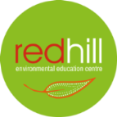
RED HILL ENVIRONMENTAL EDUCATION CENTRE

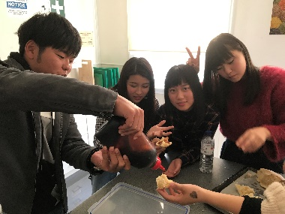
Red Hill would like to welcome to Miss Karen Morris for term 3. Karen brings a lot of knowledge and expertise in Aboriginality and its History as well as Geography. Red Hill has been very busy over the last few weeks looking towards booking schools in for future programs and designing new and outcome based programs in line with the Departments recent and ongoing changes. Recently we have had Mudgee High School’s Japanese exchange program visit us for a Gold Experience and Aboriginal Educational program. Activities such as gold panning, assembling tents, damper making and Aboriginal art and visiting the ‘Gulgong Gold Experience’ and ‘Pioneer Museum’. We would like to make a special thank you to the Pioneer Museum staff for donating packs of cards for all students displaying a photo of Gulgong on them as well as handing special Gulgong postcards to the teachers for their memories of visiting Gulgong.
HOW HARD CAN IT BE TO PUT A TENT UP?
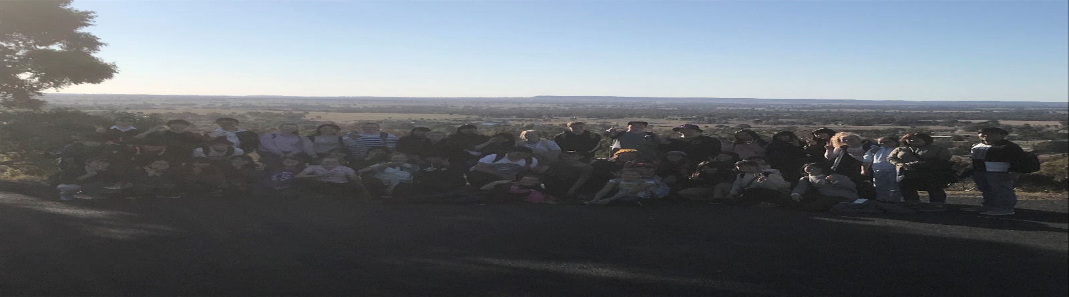
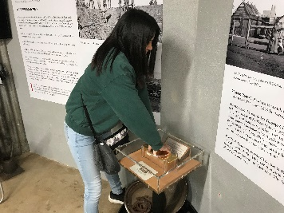
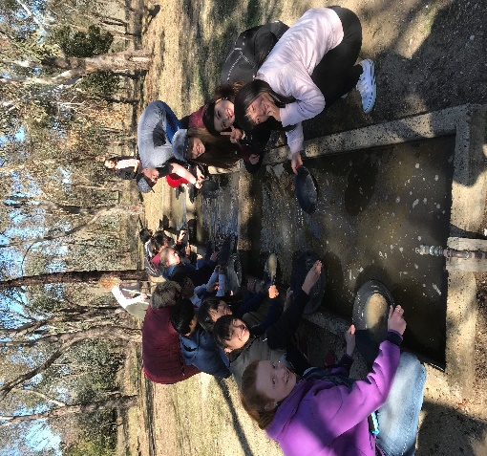
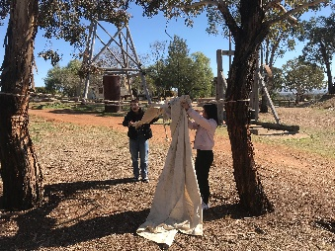
Red Hill Environmental Education Centre are looking towards utilising their current status and becoming a more public facility as we have a lot of room to move and can accommodate a lot of activities. We have cheap accommodation, user-friendly kitchen, and large areas to entertain or hold a small conference / meeting. Red Hill have some projects that they are looking into to make connections with the community and Red Hill.
Red Hill have a lot of students staying overnight and are seeking donations of any old board games, pool tables etc. that we could use to entertain students during evening visits. If you could contact Steve Haney on 6374 2558.
Here is a few sample photos of our Japanese friends enjoying the outdoors and gaining hands on EXPERIENCES to learning.

